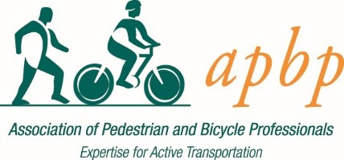

CHAPTERS
Primary Goals of APBP Local Chapters

- Help APBP members succeed
- Connect and engage APBP members
- Grow APBP member knowledge and expertise
- Put a local face on APBP
- Create a feedback loop between APBP and APBP members
- Strengthen and grow the profession locally
- Promote interdisciplinary conversation and collaboration
- Work across disciplines to achieve local active, sustainable transportation goals
- Inspire creativity across jurisdictions and political divides
- Add value to and expand APBP membership

Five Recommended Elements of APBP Local Chapters
- Member Benefits
- Social & networking events
- Mentor opportunities
- Contribute to the profession
- Engage with APBP

- Program Diversity
- Meet-ups – purely social or with program elements
- Panels
- Pecha Kucha sessions
- Presentations by thought leaders and subject matter experts
- Active Transportation Tours (i.e. Complete Streets tours)
- Women Cycling Summit

- Professional Development
- Host local and regional conferences
- Host APBP webinars
- Host APBP on-site workshops (accessibility, bicycling parking, complete streets)

- Effective Communication
- To, from and between members
- With other APBP chapters
- Ensure strong member input into APBP programming
- With other organizations
- With local and regional government by recommending policies & engagement in public discussion

- Outreach
- Students/academic programs
- Bicycle Pedestrian Advisory Committees
- Professionals in advocacy organizations
- Pro bono work in underserved communities (e.g. walk and bike audits)
- Senior mobility
- Schools, parks, transit (Safe Routes to School; to Parks, to Transit)
Support From APBP National
- Financial Support
- APBP makes $100 per year available to each Chapter to support Chapter designated activities/events meeting the following guidelines:
- Funds may be used for food, non-alcoholic beverages, signage, exhibit tables at approved conferences/events, fliers, brochures, or other approved promotional materials. If you would like to use funds for something not mentioned here, please contact national headquarters at info@apbp.org with your specific request.
- Funds will be distributed as a reimbursement. Please submit your reimbursement request within one month of the usage date using this form.
- Chapter Page on APBP Website
- APBP will create a Chapter page on our site: apbp.org. Lauren Mangnall will create the page for you and contact you when it’s ready for use.

Thank you for your interest in starting an APBP Chapter!

